Regulations:
A14

H.T No

Sreenidhi Institute of Science and Technology
(An Autonomous Institution)
Code No: 4B616 Date: 31-May-2019 (FN)

B.Tech III-Year II-Semester External Examination, May/June-2019 (Supplementary)
Principle of Finite Element Method (ME)

Time: 3 Hours Max.Marks:70

Note: a) No additional answer sheets will be provided.
b) All sub-parts of a question must be answered at one place only, otherwise it will not be valued.
c) Missing data can be assumed suitably.

Part - A Max.Marks:20

Answer all QUESTIONS.

1. | What is meant by strong and weak forms of a differential equations? | [2M]
2. | Distinguish between truss and bar element. | [2M]
3. | What is the difference between plane stress and plane strain problems? | [2M]
4. | What is meant by Jacobian matrix ? What is its importance in finite element method? | [2M]
5. | Write the one-dimensional element equations for a fin with and without convective heat loss at the tip of the fin. | [2M]
6. | List different stages in solving a problem using finite element software packages. | [2M]
7. | How do you relate global and local coordinate systems for 1-D problems? | [2M]
8. | What is the importance of iso parametric formulations? | [2M]
9. | What are the applications of axi symmetric problems? | [2M]
10. | What is the importance of node numbering scheme | [2M]
Part – B Max.Marks:50
ANSWER ANY FIVE QUESTIONS. EACH QUESTION CARRIES 10 MARKS.

11. |  | 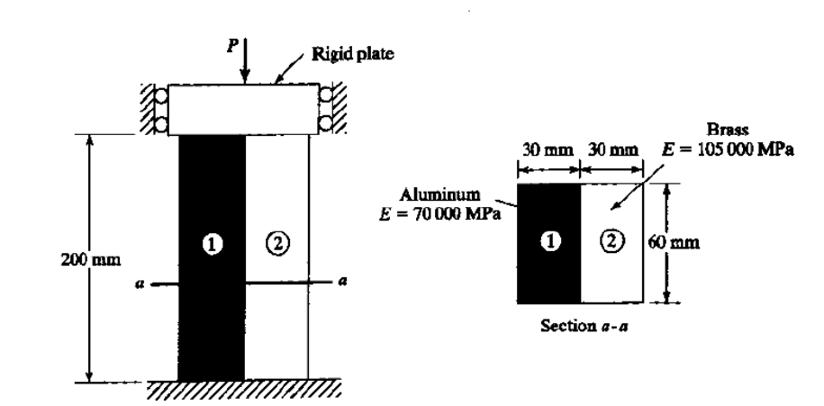  An axial load 385 KN is applied to the composite block as shown in figure . Determine the stress in each material. | [10M]
12. |  | For the two bar truss as shown in figure , determine the displacements of node 1 and the stress in element 1-3  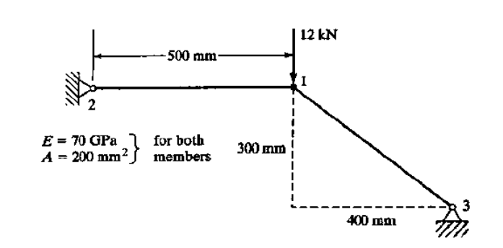 | [10M]
13. |  | Determine the deflection at the point of load application using a one-element model for the configuration shown in figure.  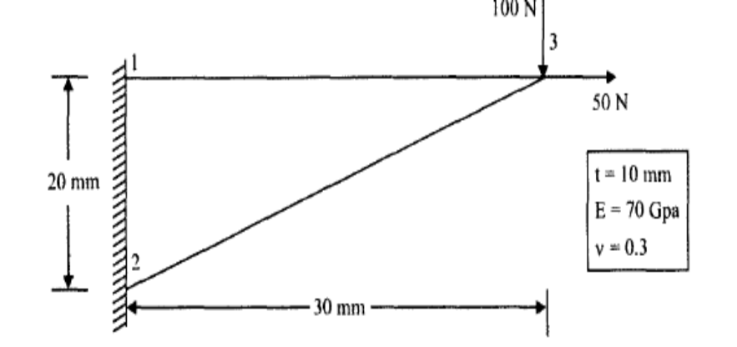 | [10M]
14. |  | Derive the shape functions for four noded quadrilateral element in natural coordinate system. | [10M]
15. |  | Heat is generated in a large plate (K = 0.4 W/m ⁰c) at the rate of 5000 W/m³ The plate is 20 cm thick. Outside surface of the plate is exposed to ambient air at 30°C with a convective heat transfer coefficient of 20 W 1m² ⁰c. Determine the temperature distribution in the wall. | [10M]
16. |  | Explain the procedure to determine the natural frequencies and mode shapes of a simply Supported beam using finite element method. | [10M]
17. | a) | Derive the equations for shape functions of two noded bar element. | [5M]
 | b) | Derive the strain displacement matrix for two dimensional triangular element. | [5M]
18. | a) | Derive the mass matrix for a two nodel bar vibration element. | [5M]
 | b) | Briefly explain 3 dimensional elements with neat sketches. | [5M]

-- 00 -- 00 –

